**Course basic information**

|  |  |  |  |  |
| --- | --- | --- | --- | --- |
| **Credit Hours** | | | **Course Name** | **Code** |
| **Total** | **Practice** | **Lecture** | **Data bases** |  |
| **3** | **1** | **2** |

**Research Title**

**( library management systems )**

|  |
| --- |
| **Student Name:حسام عبدالصادق فرج الساعدي** |
| **Student ID:1618120170100228** |
| **Level:الثالث** |
| **Department: Information system** |

Table of Contents

Library Management System…………………………………………………………………………………7

1.1 Data Dictionary………………………………………………………………………………7

1.2 Entity Relationship Diagram………………………………………………………………………………9

1.3 Select Statements using Di……………………………………………………………………………………13

afferent Functions:- ………………………………………………………………………………………14

1.4 Select Statements using Sub Query…………………………………………………………………………………14

1.5 Select Statements using Count and Group Functions……………………………………………………………………………15

1.6 Select Statements using Different Joins………………………………………………………………………………16

1. 7 Insert Statement: ………………………………………………………………………………………17

1. 8 Update Statement…………………………………………………………………………18

**Abstract**

**Introduction**

**1.**  Library Management System:-

A Library Management System is a software built to handle the primary housekeeping functions of a library. Libraries rely on library management systems to manage asset collections as well as relationships with their members. Library management systems help libraries keep track of the books and their checkouts, as well as members’ subscriptions and profiles.

Library management systems also involve maintaining the database for entering new books and recording books that have been borrowed with their respective due dates.

A library is a collection of organized information and resources which is made accessible to a well-defined community for borrowing or reference sake. The collection of the resources and information are provided in digital or physical format in either a building/room or in a virtual space or even both. Library’s resources and collections may include newspapers, books, films, prints, maps, CDs, tapes, videotapes, microform, database etc.

Library Management System allows the user to store the book details and the customer details. The system is strong enough to withstand regressive yearly operations under conditions where the database is maintained and cleared over a certain time of span. The implementation of the system in the organization will considerably reduce data entry, time and also provide readily calculated reports.

**1.1** Data Dictionary**:-**

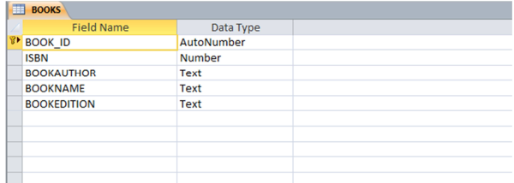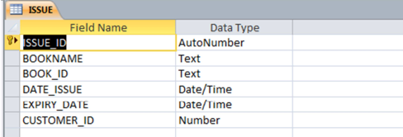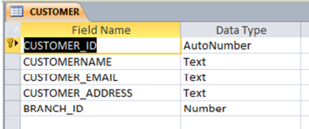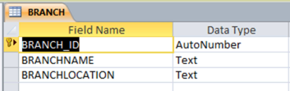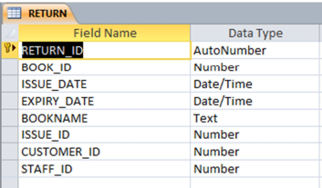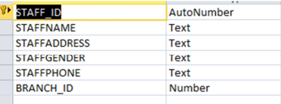

**1.2** Entity Relationship Diagram**:-**

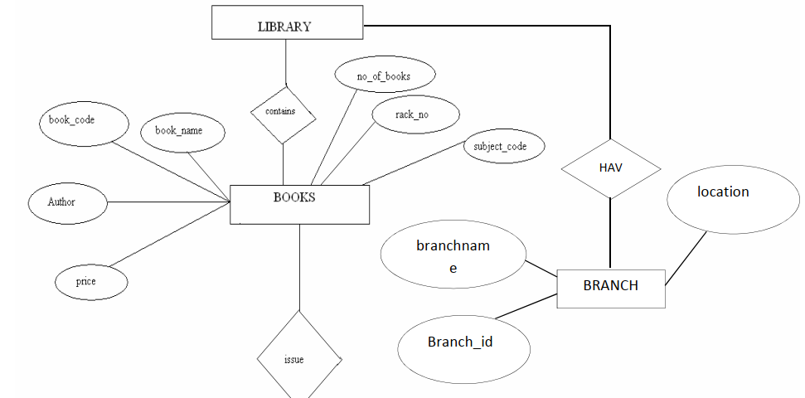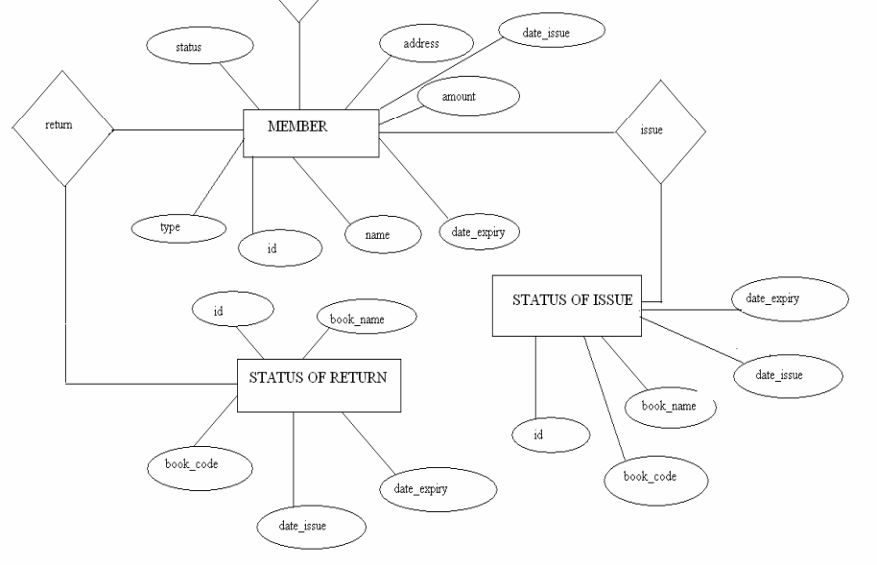

**1.3** Select Statements using Different Functions**:-**

**Problem # 1:**

Write a query to display the member id, member name, city and membership status who are all having life time membership. Hint: Life time membership status is “Permanent”.

**Ans**: select member_id,member_name,city,membership_status from LMS_MEMBERS where membership_status='permanent'

**Problem # 2:**

Write a query to display the book code, publication, price and supplier name of the book witch is taken frequently.

**Ans**: SELECT b1.book_code,b2.publication,b2.price,b3.supplier_name FROM(SELECT b1.book_code FROM LMS_BOOK_ISSUE b1 GROUP BY book_code HAVING COUNT(b1.BOOK_CODE) > 1) b1 JOIN LMS_BOOK_DETAILS b2 ON b1.book_code = b2.book_code JOIN LMS_SUPPLIERS_DETAILS b3 ON b2.supplier_id = b3.supplier_id

**Problem # 3:**

Write a query to display the member id, member name who have taken the book with book code 'BL000002'.

**Ans**: select b1. member_id,b1.member_name,b2.book_code from LMS_MEMBERS b1,LMS_BOOK_ISSUE b2 where b2.BOOK_CODE='BL000002'

**Problem # 4:**

Write a query to display the book code, book title and author of the books whose author name begins with 'P'.

**Ans**: select book_code,book_title,author from LMS_BOOK_DETAILS where AUTHOR like 'P%'

**Problem # 5**:

Write a query to display the total number of Java books available in library with alias name ‘NO_OF_BOOKS’.

**Ans**: select COUNT(category)as NO_OF_BOOKS from LMS_BOOK_DETAILS where CATEGORY='JAVA'

**Problem # 6:**

Write a query to list the category and number of books in each category with alias name ‘NO_OF_BOOKS’.

**Ans**: select category,COUNT(category)as NO_OF_BOOKS from LMS_BOOK_DETAILS group by CATEGORY

**Problem # 7:**

Write a query to display the number of books published by "Prentice Hall” with the alias name “NO_OF_BOOKS”.

**Ans**: select COUNT(publication) as NO_OF_BOOKS from LMS_BOOK_DETAILS where PUBLICATION='Prentice Hall'

**Problem # 8:**

Write a query to display the book code, book title of the books which are issued on the date "1st April 2012".

**Ans**(without issue_date): select b1.book_code,b2.book_title from LMS_BOOK_ISSUE b1 inner join LMS_BOOK_DETAILS b2 on b1.BOOK_CODE=b2.BOOK_CODE where b1.DATE_ISSUE='2012-04-01'

**Ans**(with issue date): select b1.book_code,b1.DATE_ISSUE,b2.book_title from LMS_BOOK_ISSUE b1 inner join LMS_BOOK_DETAILS b2 on b1.BOOK_CODE=b2.BOOK_CODE where b1.DATE_ISSUE='2012-04-01'

**Problem # 9:**

Write a query to display the member id, member name, date of registration and expiry date of the members whose membership expiry date is before APR 2013.

**Ans**: select member_id,member_name,DATE_REGISTER,DATE_EXPIRE from LMS_MEMBERS where DATE_EXPIRE < '2013-04-01'

**Problem # 10:**

Write a query to display the member id, member name, date of registration, membership status of the members who registered before "March 2012" and membership status is "Temporary"

**Ans**: select member_id,member_name,DATE_REGISTER,MEMBERSHIP_STATUS from LMS_MEMBERS where DATE_REGISTER < '2012-03-01' and MEMBERSHIP_STATUS='Temporary'

**Problem #11:**

Write a query to display the member id, member name who’s City is CHENNAI or DELHI. Hint: Display the member name in title case with alias name 'Name'.

**Ans**: select member_id,member_name as 'Name' from LMS_MEMBERS where CITY='chennai' or CITY='delhi'

**Problem #12:**

Write a query to concatenate book title, author and display in the following format.

Book_Title_is_written_by_Author

Example: Let Us C_is_written_by_Yashavant Kanetkar

Hint: display unique books. Use “BOOK_WRITTEN_BY” as alias name.

**Ans**: select book_title + '_is_written_by' + author as 'BOOK_WRITTEN_BY' from LMS_BOOK_DETAILS

**Problem #13:**

Write a query to display the average price of books which is belonging to ‘JAVA’ category with alias name “AVERAGEPRICE”.

**Ans**: select AVG(price) as 'AVERAGEPRICE' from LMS_BOOK_DETAILS where CATEGORY='java'

**Problem #14:**

Write a query to display the supplier id, supplier name and email of the suppliers who are all having gmail account.

**Ans**: select supplier_id,SUPPLIER_NAME,EMAIL from LMS_SUPPLIERS_DETAILS where EMAIL like '%gmail.com'

**Problem#15:**

Write a query to display the supplier id, supplier name and contact details. Contact details can be either phone number or email or address with alias name “CONTACTDETAILS”. If phone number is null then display email, even if email also null then display the address of the supplier. Hint: Use Coalesce function.

**ANS**: select Supplier_id,supplier_name,coalesce(contact,email,address) as contactdetails from Lms_suppliers_details

**Problem#16:**

Write a query to display the supplier id, supplier name and contact. If phone number is null then display ‘No’ else display ‘Yes’ with alias name “PHONENUMAVAILABLE”. Hint: Use ISNULL.

**ANS**: select SUPPLIER_ID,SUPPLIER_NAME,case when CONTACT is NULL then 'NO' when CONTACT is not null then 'YES' end as PHONE_NUM_AVAILABLE from LMS_SUPPLIERS_DETAILS

**Problem#17:**

Write a query to display the member id, member name, city and member status of members with the total fine paid by them with alias name “Fine”.

**ANS**: SELECT m.MEMBER_ID, m.MEMBER_NAME, m.CITY, SUM(f.FINE_AMOUNT) AS FINE FROM LMS_MEMBERS m INNER JOIN LMS_BOOK_ISSUE i ON m.MEMBER_ID = i.MEMBER_ID INNER JOIN LMS_FINE_DETAILS f ON i.FINE_RANGE = f.FINE_RANGE GROUP BY m.MEMBER_ID, m.MEMBER_NAME, m.CITY.

**Problem # 18:**

Write a query to display the member id, member name of the members, book code and book title of the books taken by them.

**ANS**: select MEMBER_ID,(select MEMBER_NAME from LMS_MEMBERS where MEMBER_ID=t1.MEMBER_ID )as MEMBER_NAME,BOOK_CODE,(select BOOK_TITLE from LMS_BOOK_DETAILS where BOOK_CODE=t1.BOOK_CODE)as BOOK_TITLE from LMS_BOOK_ISSUE t1

**Problem # 19**:

Write a query to display the total number of books available in the library with alias name “NO_OF_BOOKS_AVAILABLE” (Which is not issued). Hint: The issued books details are available in the LMS_BOOK_ISSUE table.

**ANS**: SELECT COUNT(t1.BOOK_CODE)AS NO_OF_BOOKS_AVAILABLE FROM LMS_BOOK_DETAILS t1 LEFT JOIN LMS_BOOK_ISSUE t2 ON t1.BOOK_CODE = t2.BOOK_CODE WHERE t2.BOOK_CODE IS NULL

**Problem # 20:**

Write a query to display the member id, member name, fine range and fine amount of the members whose fine amount is less than 100.

**ANS**: SELECT T1.MEMBER_ID,(SELECT MEMBER_NAME FROM LMS_MEMBERS WHERE MEMBER_ID=T1.MEMBER_ID)AS MEMBER_NAME,(SELECT T2.FINE_RANGE FROM LMS_MEMBERS WHERE MEMBER_ID=T1.MEMBER_ID)AS FINE_RANGE,(SELECT FINE_AMOUNT FROM LMS_FINE_DETAILS T2 WHERE FINE_RANGE= T1.FINE_RANGE)AS FINE_AMOUNT FROM LMS_BOOK_ISSUE T1 LEFT JOIN LMS_FINE_DETAILS T2 ON T1.FINE_RANGE = T2.FINE_RANGE WHERE T2.FINE_AMOUNT < 100

**1.4** Select Statements using Sub Query**:-**

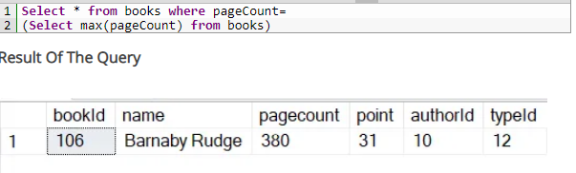

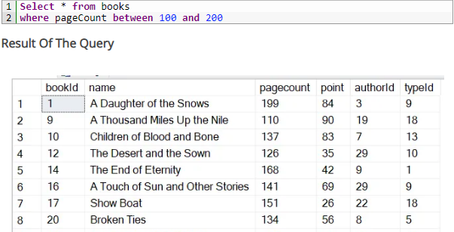

**Figure 2**

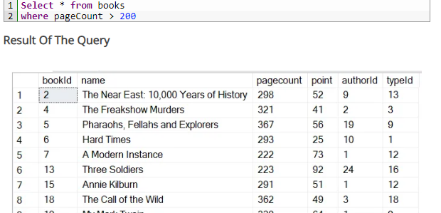

**Figure 3**

**1.5** Select Statements using Count and Group Functions**:-**

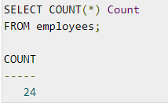

**Figure 1**

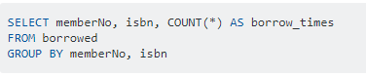

**Figure 2**

**1.6** Select Statements using Different Joins**:-**

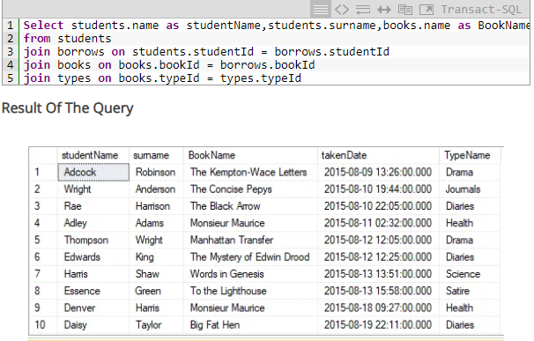

**Figure 1**

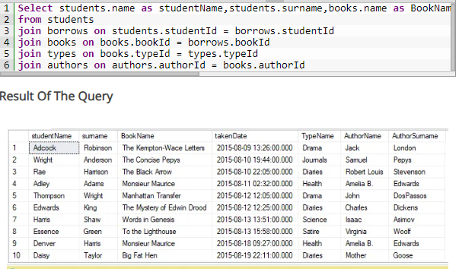

**Figure** 2

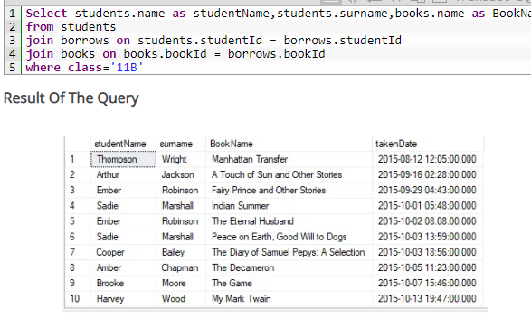

**Figure 3**

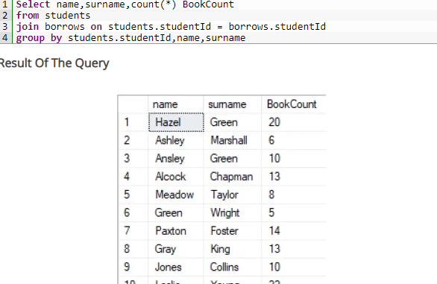

**Figure 4**

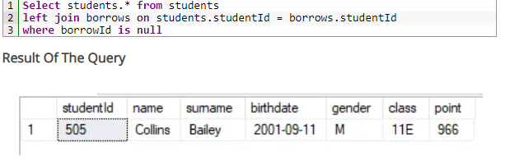

**Figure 5**

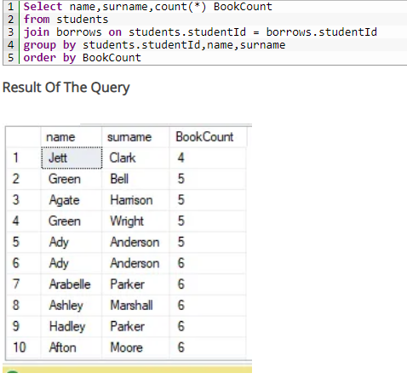

**Figure 6**

**1. 7** Insert Statement**:-**

**C:\Users\RaMzy\Desktop\5555555.PNG**

**Figure 1**

**C:\Users\RaMzy\Desktop\1111111.PNG**

**Figure 2**

**C:\Users\RaMzy\Desktop\22222.PNG**

**Figure 3**

**C:\Users\RaMzy\Desktop\3333333.PNG**

**Figure 4**

**C:\Users\RaMzy\Desktop\4444444.PNG**

**Figure 5**

**1.** **8** Update Statement**:-C:\Users\RaMzy\Desktop\11.PNG**

**Figure 1**

**C:\Users\RaMzy\Desktop\22.PNG**

**Figure 2**

**C:\Users\RaMzy\Desktop\33333333333.PNG**

**Figure 3**

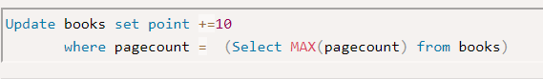

**Figure 4**

**C:\Users\RaMzy\Desktop\6666666.PNG**

**Figure 5**

**1.** **9** Delete Statement**:-**

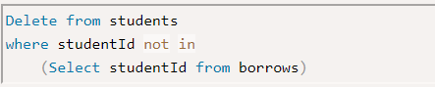

**Figure 1**

**C:\Users\RaMzy\Desktop\222222.PNG**

**Figure 2**

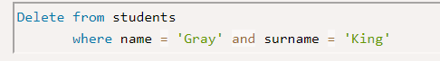

**Figure 3**

**C:\Users\RaMzy\Desktop\55555555555555.PNG**

**Figure 4**

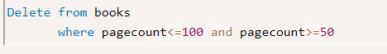

**Figure 5**

**References:-**

[1] Alka Khurana 01/10/2013, LIBRARY MANAGEMENT SYSTEM .

[2] <http://programtechn.blogspot.com/2013/06/sql-query-library-management-system.html>

[3] <https://www.queryexamples.com/sql/general/library-database-sql-query-examples/>

[4] http://mattben.info/media/pdf/370_ImplementationPhase.pdf